Date | December 10, 2024
Subject | Constitution of the Proof Of Concept RATB Working Group
Participants | 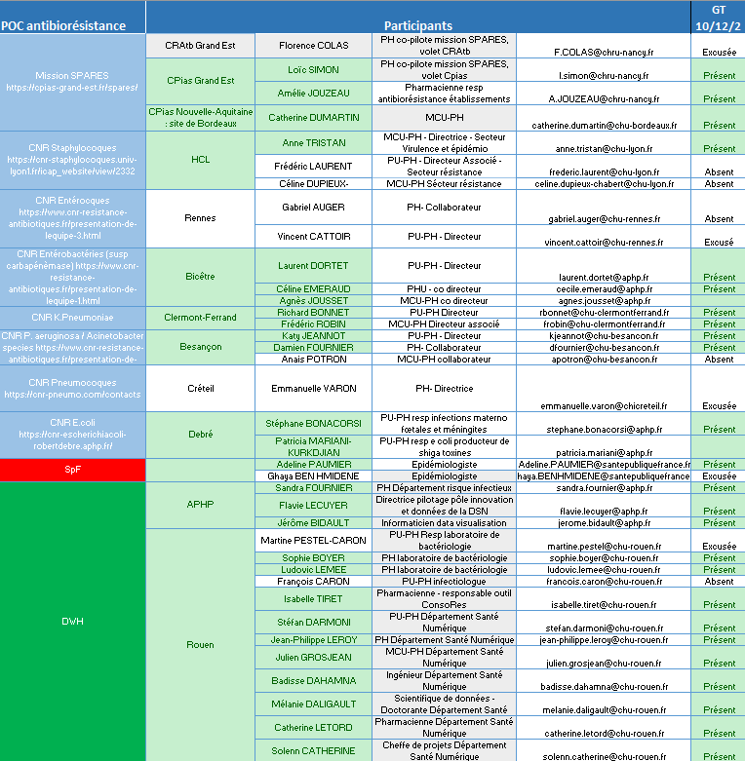
Site | Hybrid (face-to-face: DéSaN meeting room + remote: Zoom room)

CONTEXT
- ORCHIDEE PROJECT: Organization of a Network of Hospitals Involved in Epidemiological Surveillance and Response to Emergencies,

- Project funded by the European Commission to the tune of 9.2 million euros as part of the EU4Health program, Call: EU4H-2023-DGA-MS3-IBA,

- Project duration 48 months: 01/10/2024-30/09/2028,

- Supported by Santé publique France (SPF), Plateforme des Données de Santé (PDS or HDH for Health Data Hub) and Bordeaux Population Health (BPH), research center U1219 + consortium of 25 UHC : Amiens, Angers, Assistance Publique - Hôpitaux de Paris, Besançon, Bordeaux, Brest, Caen Normandie, Dijon, Grenoble, Guadeloupe, Lille, Limoges, Lyon, Martinique, Metz-Thionville, Montpellier, Nantes, Nancy, Nice, Poitiers, Reims, Rennes, Rouen, Strasbourg, Tours).

TOPICS
- Round table of participants

- ORCHIDEE project objectives

ORCHIDEE's main objective is to provide the authorities with high-quality epidemiological indicators, enabling them to assess the epidemiological situation in hospitals in near-real time. To achieve this, the concept of “secondary use of data” is favored, so that indicators can be produced from existing hospital data, without the need for healthcare professionals to enter additional information twice, and thus avoid wasting time. This model is destined to become more widespread, strengthening national, regional and European capacities to monitor diseases and make the most of the health data entered daily by hospitals.
Currently, most of these indicators are available on an annual basis. One of ORCHIDEE's objectives is to obtain these indicators on a weekly basis.

- ORCHIDEE proofs of concept

ORCHIDEE has five proofs of concept (or use cases).
The priority is operational surveillance of SARI (Severe Acute Respiratory Infections) for the coming 2025/2026 season.
Next,
- Antibiotic resistance
- Severe bacterial infections
- Healthcare-associated infections (HAIs)
- Arboviroses

Antibiotic resistance in healthcare establishments is currently monitored by the SPARES mission, in collaboration with SpF. The ConsoRes2 tool will be operational in June 2025 (L. Simon). Local tools are also used in some establishments. Others are already using data from their EDS to carry out specific queries.

- Antibiotic resistance indicators

Epidemiological indicators developed by hospitals will be forwarded to Santé publique France, which will centralize, compile, interpret and report them.
These indicators should be available in all hospitals = simple indicators in the first instance.

Antibiotic resistance monitoring by SPARES is currently based on antibiotic consumption and the characterization of bacterial resistance to antibiotics.

- Evaluation of antibiotic consumption - methodology :

The quantity of common dispensing units (CDU) dispensed for each presentation of an antibiotic, i.e. the number of tablets, sachets, ampoules, bottles of oral solution, etc. for each pharmaceutical form marketed, is collected from data supplied by in-house pharmacies (PUI). To calculate the number of DDDs (days of treatment at the reference dosage), we need the total quantity in grams of the antibiotic concerned and divide this quantity by the DDD value in grams for the same antibiotic.
Thus, DDDs should be considered as units of measurement and do not necessarily reflect the prescribed or recommended daily doses (particularly when taking into account pharmacokinetic or individual characteristics such as weight, age, renal insufficiency, etc.).
These consumption figures, presented in number of DDDs, give a general estimate of consumption.

Advantages of this indicator :
- it is easy to implement;
- it enables the consumption of a given antibiotic to be compared between different geographical areas, since the number of units sold is expressed in a common reference form.
Limits of this indicator :
- it does not in itself provide information on the number of people exposed during the period. This makes it difficult to interpret the importance of antibiotic exposure outside the context of geographical or temporal comparisons. Nevertheless, this unit is perfectly suitable for establishing spatio-temporal comparisons between antibiotic exposure and antibiotic resistance rates;
- it makes it difficult to interpret comparisons when the doses or durations actually prescribed vary from one population to another.

Objective = build on existing data to define a core set of ORCHIDEE indicators, and move towards a more refined measurement based on “consumption” (delivery to the patient) using data from the HCDW (Hospital Clinicals Data Warehouse).
- Characterization of bacterial resistance to antibiotics - methodology :
Characterization of the percentage of resistance within the species, in addition to incidence in relation to activity, by collecting data on all strains, susceptible and resistant strains.

There are several points to bear in mind:

- The MALDI-TOF technique is less accurate than the NCBI Taxonomy classification (L. Dortet), integrated into the HeTOP terminology server (URL: www.hetop.eu).
- The question of standardization of results arises: resistance mechanisms are not reported in Europe, nor are they routinely performed in France.
- The level of species/subspecies results will have to be decided by expert consensus, depending on the strain studied.
- Heterogeneous practices exist with regard to the tools and expression of results to be studied in each hospital. It is important to qualify the technique, the automaton, the reference system...

COMMENTS / DECISIONS
- Proposal to study the expression of bacteriology results at Rouen University Hospital, then check standardization with APHP and Bordeaux.

- Breakdown of the RATB WG into 2 separate WGs for each indicator. 1 ATB consumption WG and 1 bacterial resistance WG.

- Indicator plot v1 to be sent to the WG in December for approval + call for expressions of interest to confirm participation in the WG.

- Reminder of expectations from the WG = validate the methodology for each indicator. Enrich indicators in 2nd intention.
NEXT MEETING
To be defined.

